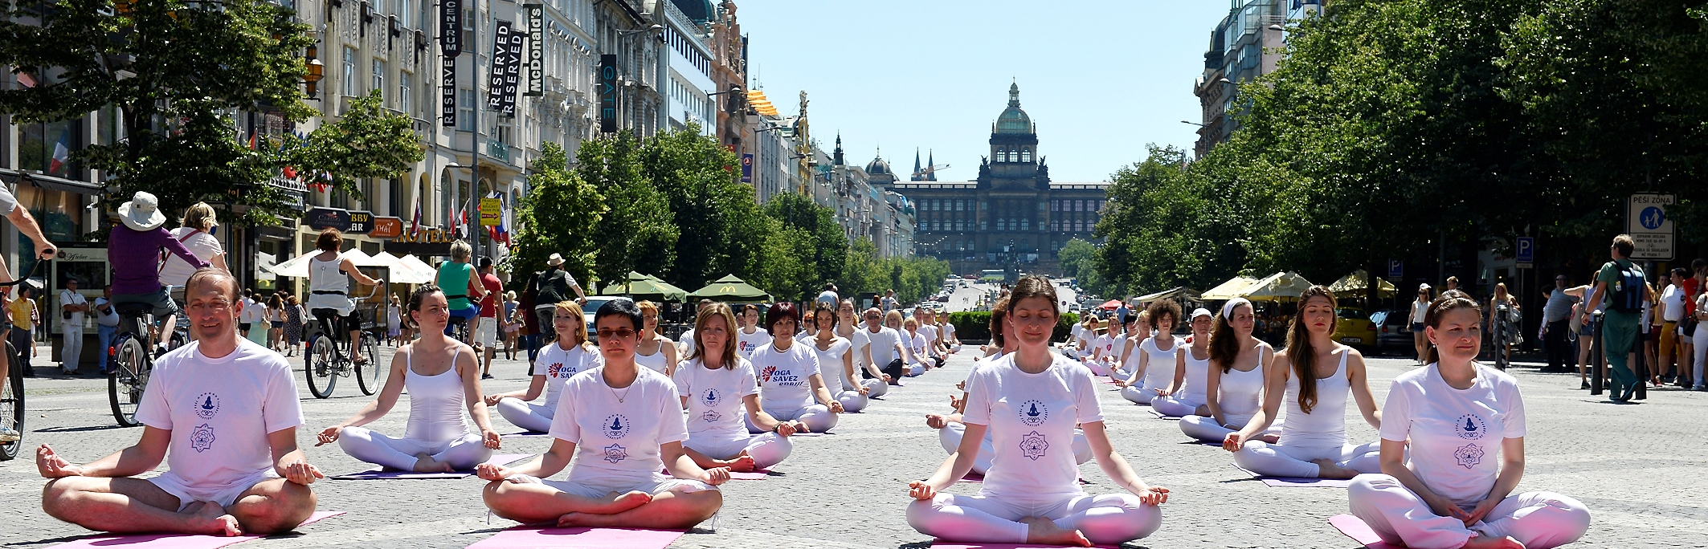

APPLICATION

YOGA DAYS OF GOOD DEEDS, PRAGUE 2015

Name:

Surname:

Name of yoga center:

City:

Country:

E-mail:

Phone:

I practice yoga: YES NO

I confirm that I am healthy and I have a medical confirmation that I can participate in the performance Yoga Days Of Good Deads 2015, in Prague.

Date:

